Appendix 1: The picture of caring in our survey

The carers who completed our survey
- Our survey focused on carers caring for people over the age of 18 so that our scope was not too wide. It is worth noting that we had many more responses that were from parent carers of someone under the age of 18 (17 responses).
- Our survey was also limited to people living within Bath and North East Somerset Swindon and Wiltshire (BSW).
- The majority of responses to the survey came from Wiltshire. We have tried to balance this by holding our interviews in Swindon and Bath and North East Somerset (BANES).

Survey responses that were not from BANES, Swindon or Wiltshire came from:
- Dorset (2 responses)
- Hampshire (1 response)
- North Somerset (1 response)

Ethnicity of carers
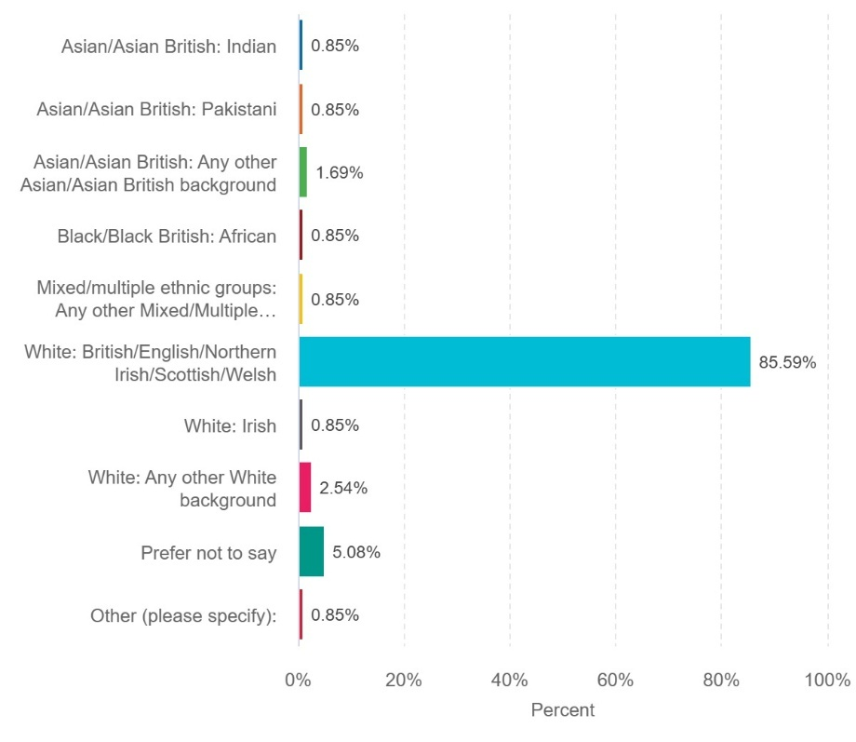
- 85.6% of respondents to our survey were White British / Northern Irish / Welsh / Scottish.
- Those who described their ethnicity as other stated their ethnicity to be white British.
- Opposite is a full breakdown of all the ethnicities of carers who responded to our survey:

- Most carers who responded to our survey were female.
- However, we have included sections on the unique experience of male carers in this report and our second report on carers’ experiences in BSW.

Age of carers
- Nearly half (45%) of the carers who responded to our survey said they were aged 50-64.

People that are being cared for:
Our survey showed that carers are caring for people with a wide range of conditions that often co-exist. This accounts for the total number of people with a condition being higher than the overall number of responses to the survey.
Name of condition | Number of people
Person with a physical disability or mobility issues | 26
Person with learning disabilities | 23
Person with serious mental illness | 21
Person with dementia or Alzheimer’s disease | 16
Person with another long term health condition | 14
Autism | 12
ADHD | 6
Addiction | 4
Terminal illness | 3
Cerebral Palsy | 1
Epilepsy | 1
Anxiety | 1
Borderline personality disorder | 1
Eating disorder | 1
Diabetes | 1
TOTAL | 131

Age of person being cared for
There was a lot of diversity in the ages of the people being cared for across BSW.

Relationship to the person
- 92% of respondents said the person they care for is a family member.
- 74.5% of respondents said the person they care for lives at home with them.
- Lots of respondents said they care for someone because they are family and they have a duty to do so.

