Appendix

List of service providers:
- CAMHS
- Primary care provider
- HCRG School Nurses - School Aged Health Service Programme
- RUH Children’s A&E
- University of Bath
- Norland College
- Bath Mind
- Avon and Wiltshire Mental Health Partnership NHS Trust: AE Liaison Team
- Trauma Recovery Centre
- Learning Disability Team at RUH
- Occupational Health Nurse
- Feedback from member organisations at the Mental health Alliance

Services which we did reach out to but were unable to get feedback from:
- OTR
- Adult A&E at RUH
- Second Steps
- Turning Point
- Boys In Mind

Service directory tool (current moment in time)
We recognise the limitations of service directories becoming outdated quickly, however, due to the request of all the people we spoke to desiring a better overview of available services, we decided to play around with a potential framework based on the i-THRIVE model where support services can be outlined. This is open for comments, suggestions and discussion.
Please let us know if any mental health services are not represented in this overview.

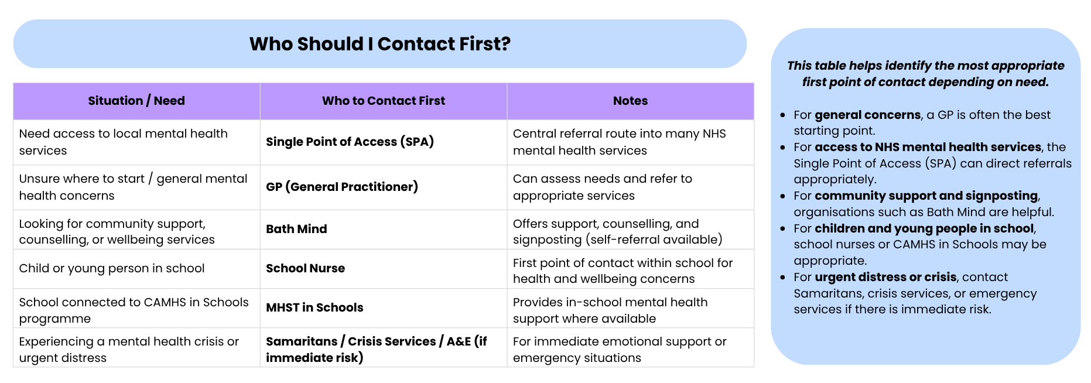

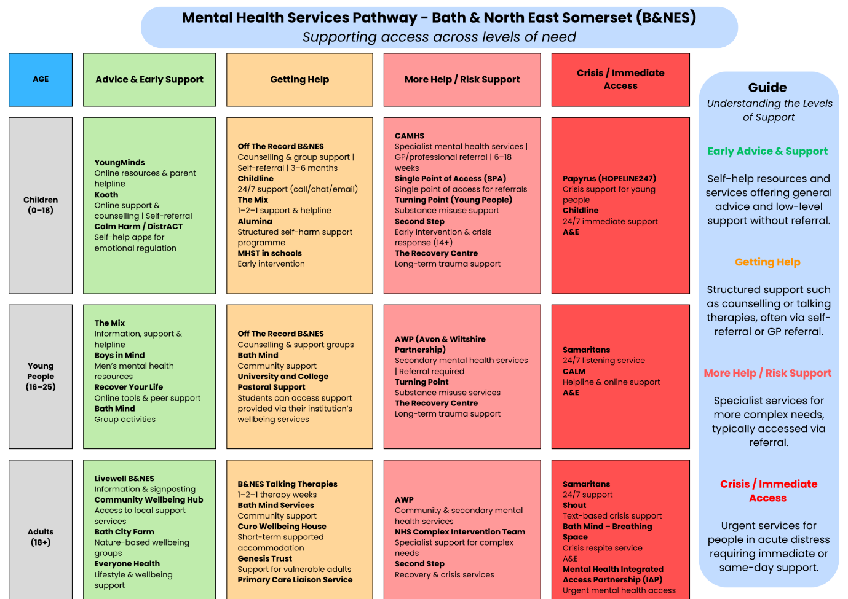

Questions for carers/lived experiences and service providers

Questions for carers/people with lived experience
Core question 1: Accessibility
- Main question: Which service providers have you received help from?
- Main question: What was your experience of finding these services and getting signed up to receive support?
- Prompts:
  - Did you have any difficulties or positive experiences in finding these services and getting signed up to receive support?
  - Were you on a waiting list before being able to receive support? If so, for how long?
  - How clear was the information you were given by service providers about how to access help for self-harm?
Core question 2: Experience of the services
- Main question: Can you tell me about the support you received (if any) from each services when you experienced self-harm?
- Prompts:
  - How did these services make you feel? Did you feel supported?
  - When using these services, did you feel that your views and experiences were listened to and taken seriously?
  - Were there anything that made you feel safe or unsafe while receiving support?
  - What was your experience of the professionals who supported you?
  - What was most helpful and what was least helpful about the support you received?
Core questions 3: Identity
- Do you feel your background, identity, or personal needs influenced the support you received in any way?
- How could the services have helped better consider your personal needs?
Core question 4: Preventative Support
- Main question: What could schools and youth clubs do to help early on?
Core question 5: Crisis/Post-Crisis Support
- Main question: Thinking about the period during or after a self harm episode, what kinds of support would have felt most helpful or comforting for you?
Core question 6: Transition from CAHMS to Adult Services
- Main question: Have you moved from CAMHS to adult services? If so, what was your experience of that?
- Prompt:
  - Was there any time during this time in between services that you felt you didn’t get the help you needed?
  - Did you feel that your information was shared with the new service appropriately?
Core question 7: Missing Support
- Main question: Are there types of support you feel were missing from your experience?
- Prompt:
- If you could design the ideal support system, what would it include?
Additional feedback
- Final question: Is there anything you wish you could tell any of these service providers?

Questions for professionals
Section 1: Current Support
- What forms of support does your service currently provide to children and young people who self-harm?
- What approaches or practices within your service have been most effective in supporting young people who self-harm?
(Please describe any evidence of positive outcomes or feedback.)
- Any groups of young people you see more often in relation to self-harm (e.g., age, gender, neurodivergent, SEND, LGBTQIA+, care‑experienced, ethnicity)?
- How, if at all, does your service involve families and carers when supporting a child or young person who self-harms?
- What are the current waiting times for children and young people seeking self-harm support within your service?
- What are your criteria for taking on a person in your case load? In other words, what criteria does this person need to meet to be offered support?
Section 2: Referral Pathways and Access
- How do self-harm referral pathways work within your service, and how do you typically link with other services or agencies?
- From your perspective, what improvements would make referral processes smoother or clearer for both your service and for the young people you support, including transitioning from children’s to adult’s services?
- In what ways do current referral capacity thresholds help or hinder your service’s ability to support young people who self‑harm?
- How big a factor is self-harm playing in determining someone being referred/accepted to your service?
Section 3: Challenges in Service Delivery
- What are the key challenges your service faces when supporting children and young people who self-harm?
- Are there particular resource, workforce, or system-related factors that affect your ability to provide timely or effective care?
- How well supported do staff feel when working with children and young people who self-harm?
- Has staff received the appropriate training, including trauma-informed training?
Section 4: Gaps and Opportunities
- Where do you see the biggest gaps in support for children, young people, and families affected by self-harm?
- If you could prioritise one change or improvement in self-harm support for young people over the next year, what would it be and why?
- Are there any preventative approaches or early-help strategies you believe could strengthen support for young people who self-harm?
Section 5: Additional Feedback
- Is there anything else you would like to share that hasn’t been covered but you feel is important for us to understand?

